For each task, you need to provide a solution in the form of a flowchart, which will display the pseudocode of each task.

**Task 1.**

Display the pseudocode in the form of a block diagram.

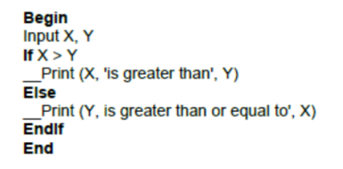

What is the minimum number of test cases required to guarantee 100% statement and 100% decision coverage?

A. Statement coverage = 3, Decision coverage = 3

B. Statement coverage = 2, Decision coverage = 2

C. Statement coverage = 1, Decision coverage = 2

D. Statement coverage = 2, Decision coverage = 1

**Task 2.**

Display the pseudocode in the form of a block diagram.

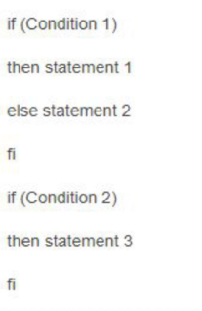

What is the minimum number of test cases required to guarantee 100% path coverage?

A. 1

B. 2

C. 3

D. No answer is correct

**Task 3.**

Display the pseudocode in the form of a block diagram.

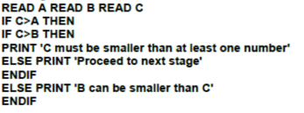

What is the minimum number of test cases required to guarantee 100% statement and 100% decision coverage?

A. 2, 4

B. 3, 2

C. 3, 3

D. 2, 3

**Task 4.**

Display the pseudocode in the form of a block diagram.

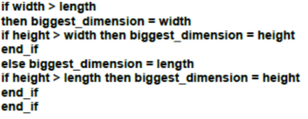

What is the minimum number of test cases required to guarantee 100% decision coverage?

A. 3

B. 4

C. 1

D. 2

**Task 5.**

If you fly in economy class, you can be upgraded to business class, especially if you have the airline's gold card for private flights. If you don't have a gold card, you may be bumped off the flight if the plane is overcrowded or you are late for check-in. All these conditions are shown in the diagram below.

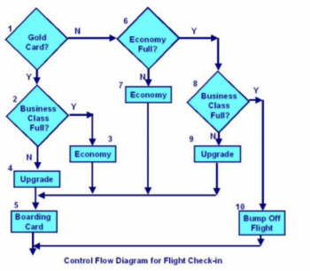

You run 3 tests:

Test 1 - Gold card holder upgraded to business class

Test 2 - A passenger without a gold card remains in economy class Test 3 - A passenger who was bumped off the flight

What is the statement coverage of the three tests?

A. 60%

B. 70%

C. 80%

D. 90%

